Angebot freibleibend - Zwischenverkauf vorbehalten free offer - subject to prior sale



Baby - Pflegeprodukte / Gentle baby care products

dermatologically tested - free from parabens, mineral oils and artificial fragrances! Ideal for newborns, babies and toddlers.

Photo | Art.-Nr. | PZN  pharma no. | GTIN - VBE / EAN | Bezeichnung / Description | Sprache / language | VE / PU | carton  p. pal. | pcs. p. pallet | Anzahl Pal qty. pal | Stückzahl quantity | UVP / RRP /  pc € | total UVP RRP
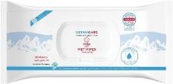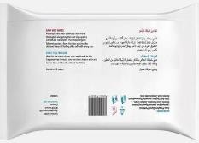 | 401397 | 18067134 | 4000196401380 | GermaCare Baby Feuchttücher / wet wipes 60 pcs / bag | E/A | 12 | 84 | 1.008 | 49 | 49.056 | 5,99 € | 293.845,44 €
Total |  |  |  |  |  |  |  |  | 49,0 | 49.056 |  | 293.845,44 €
